Project Design Phase-II Technology Stack (Architecture & Stack)

|  |  |
| --- | --- |
| Date | 01 November 2023 |
| Team ID | 592358 |
| Project Name | Walmart Store Sales Forecasting |
| Maximum Marks | 4 Marks |

Walmart Store Sales Forecasting

Sales forecasting is the process of estimating future sales. Accurate sales forecasts enable companies to make informed business decisions and predict short-term and long-term performance. Companies can base their forecasts on past sales data, industry-wide comparisons, and economic trends. Here, the company is Walmart. Walmart is a renowned retail corporation that operates a chain of hypermarkets. Walmart has provided a data by combining the data of 45 stores including store information and monthly sales. Walmart runs several promotional markdown events throughout the year. These markdowns precede prominent holidays, the four largest of which are the Super Bowl, Labor Day, Thanksgiving, and Christmas. The weeks including these holidays are weighted five times higher in the evaluation than non-holiday weeks. The data is provided on weekly basis. We have to find the impact of holidays on the sales of the store. The holidays included are Christmas, Thanksgiving, Super Bowl and Labour Day. We will be using algorithms such as ARIMA, Random Forest, and XgBoost. We will train and test the data with these algorithms. Flask integration and IBM deployment will also be done

Technical Architecture:

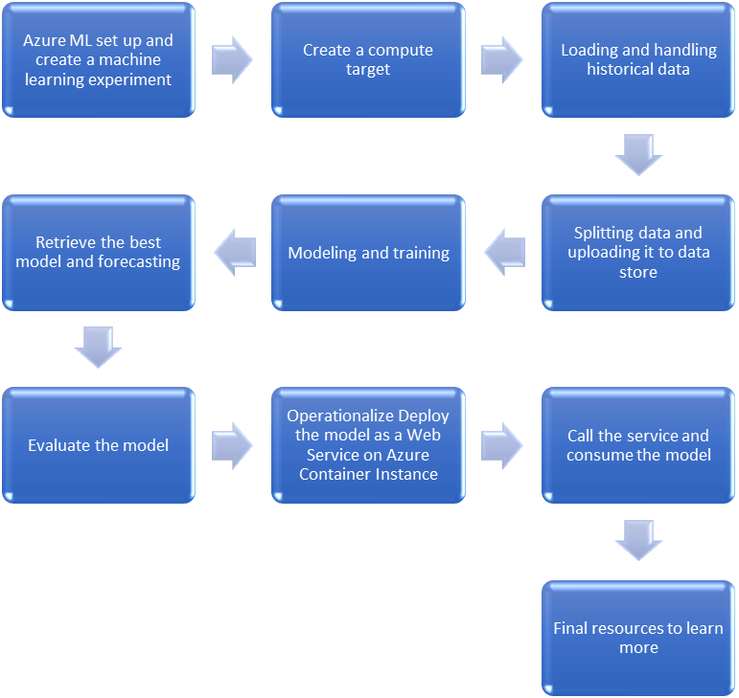

Table-1 : Components & Technologies:

|  |  |  |  |
| --- | --- | --- | --- |
| **S.No** | **Component** | **Description** | **Technology** |
| 1. | User Interface | How user interacts with application e.g. Web UI, Mobile App, Chatbot etc. | HTML, CSS, JavaScript / Angular Js / React Js etc. |
| 2. | Application Logic-1 | Logic for a process in the application | Java / Python |
| 3. | Application Logic-2 | Logic for a process in the application | IBM Watson Speech to Text (STT) service |
| 4. | Application Logic-3 | Logic for a process in the application | IBM Watson Assistant |
| 5. | Database | Data Type, Configurations etc. | MySQL, NoSQL (MongoDB, Cassandra, etc.) |
| 6. | Cloud Database | Database Service on Cloud | IBM DB2, IBM Cloudant etc. |
| 7. | File Storage | File storage requirements | IBM Block Storage or Other Storage Service or Local Filesystem |
| 8. | External API-1 | Purpose of External API used in the application | IBM Weather API, etc. |
| 9. | External API-2 | Purpose of External API used in the application | Aadhar API, etc. |
| 10. | Machine Learning Model | Purpose of Machine Learning Model | Object Recognition Model, Time Series Models, etc. |
| 11. | Infrastructure (Server / Cloud) | Application Deployment on Local System / Cloud Local Server Configuration:  Cloud Server Configuration : | Local Server, IBM Cloud Foundry, Kubernetes, etc.  . |

Table-2: Application Characteristics:

|  |  |  |  |
| --- | --- | --- | --- |
| **S.No** | **Characteristics** | **Description** | **Technology** |
| 1. | Open-Source Frameworks | Utilization of open-source frameworks in the application | Flask (Python), React (JavaScript), Express.js (Node.js) |
| 2. | Security Implementations | Implementation of security and access controls | SHA-256 for hashing, Encryption for sensitive data, IAM Controls, OWASP guidelines |
| 3. | Scalable Architecture | Justification of the scalability architecture | Microservices architecture for modularity and scalability, Kubernetes for container orchestration, Load balancing for even distribution of requests |

|  |  |  |  |
| --- | --- | --- | --- |
| **S.No** | **Characteristics** | **Description** | **Technology** |
| 4. | Availability | Justify the availability of application (e.g. use of load balancers, distributed servers etc.) | Technology used |
| 5. | Performance | Design consideration for the performance of the application (number of requests per sec, use of  Cache, use of CDN’s) etc. | Technology used |

References:

<https://c4model.com/>

<https://developer.ibm.com/patterns/online-order-processing-system-during-pandemic/> <https://www.ibm.com/cloud/architecture>

<https://aws.amazon.com/architecture>

<https://medium.com/the-internal-startup/how-to-draw-useful-technical-architecture-diagrams-2d20c9fda90d>